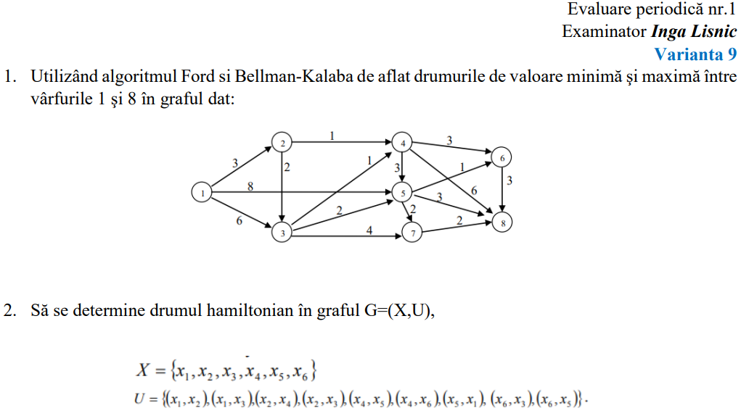

**Algoritmul Ford**

Drumul minim

|  |  |  |  |  |  |  |
| --- | --- | --- | --- | --- | --- | --- |
| Etichete | i | j | Lij | Comparare |  | Eticheta noua |
| 0 | 1 | 2 | 3 | ∞-0>3 | 0+3 | H2=3 |
| 0 | 1 | 3 | 6 | ∞-0>6 | 0+6 | H3=6 |
| 0 | 1 | 5 | 8 | ∞-0>8 | 0+8 | H5=8 |
| ∞ | 2 | 3 | 2 | 6-3>2 | 3+2 | H3=5 |
| ∞ | 2 | 4 | 1 | ∞-3>1 | 3+1 | H4=4 |
| ∞ | 3 | 4 | 1 | 4-5<1 | - | - |
| ∞ | 3 | 5 | 2 | 8-5>2 | 5+2 | H5=7 |
| ∞ | 3 | 7 | 4 | ∞-5>4 | 5+4 | H7=9 |
| ∞ | 4 | 5 | 3 | 7-4=3 | - | - |
| ∞ | 4 | 6 | 3 | ∞-4>3 | 4+3 | H6=7 |
| ∞ | 4 | 8 | 6 | ∞-4>6 | 4+6 | H8=10 |
| ∞ | 5 | 6 | 1 | 7-7<1 | - | - |
| ∞ | 5 | 7 | 2 | ∞-7>2 | 7+2 | H7=9 |
| ∞ | 5 | 8 | 3 | 10-7=3 | - | - |
| ∞ | 6 | 8 | 3 | 10-7=3 | - | - |
| ∞ | 7 | 8 | 2 | 10-9<2 | - | - |

Lmin(1 -> 8) = 10

H8-H4 -> 10-4=6

~~H4-H3 -> 4-5=-1~~

H4-H2 -> 4-3=1

H2-H1 -> 3-0=3

3+1+6=10

Drumul minim: 1->2->4->8

**Algoritmul Ford**

Drumul maxim

|  |  |  |  |  |  |  |
| --- | --- | --- | --- | --- | --- | --- |
| Etichete | i | j | Lij | Comparare |  | Eticheta noua |
| 0 | 1 | 2 | 3 | -∞-0<3 | 0+3 | H2=3 |
| 0 | 1 | 3 | 6 | -∞-0<6 | 0+6 | H3=6 |
| 0 | 1 | 5 | 8 | -∞-0<8 | 0+8 | H5=8 |
| -∞ | 2 | 3 | 2 | 6-3<2 | - | - |
| -∞ | 2 | 4 | 1 | -∞-3<0 | 0+3 | H4=3 |
| -∞ | 3 | 4 | 1 | 3-6<1 | 1+6 | H4=7 |
| -∞ | 3 | 5 | 2 | 8-6=2 | - | - |
| -∞ | 3 | 7 | 4 | -∞-6<0 | 0+6 | H7=6 |
| -∞ | 4 | 5 | 3 | 8-7<3 | 3+7 | H5=10 |
| -∞ | 4 | 6 | 3 | -∞-7<3 | 3+7 | H6=10 |
| -∞ | 4 | 8 | 6 | -∞-7<6 | 7+6 | H8=13 |
| -∞ | 5 | 6 | 1 | 10-10<1 | 10+1 | H6=11 |
| -∞ | 5 | 7 | 2 | 6-10<2 | 10+2 | H7=12 |
| -∞ | 5 | 8 | 3 | 13-10=3 | - | - |
| -∞ | 6 | 8 | 3 | 13-11<3 | 11+3 | H8=14 |
| -∞ | 7 | 8 | 2 | 14-12=2 | - | - |

Lmax(1 -> 8) = 14

H8-H6 -> 14-11=3

H6-H5 -> 11-10=1

H5-H4 -> 10-7=3

H4-H3 -> 7-6=1

H3-H1 -> 6-0=6

6+1+3+1+3=14

Drumul maxim: 1->3->4->5->6->8

**Algoritmul Bellman-Kalaba**

Drumul minim

|  |  |  |  |  |  |  |  |  |
| --- | --- | --- | --- | --- | --- | --- | --- | --- |
|  | 1 | 2 | 3 | 4 | 5 | 6 | 7 | 8 |
| 1 | 0 | 3 | 6 | ∞ | 8 | ∞ | ∞ | ∞ |
| 2 | ∞ | 0 | 2 | 1 | ∞ | ∞ | ∞ | ∞ |
| 3 | ∞ | ∞ | 0 | 1 | 2 | ∞ | 4 | ∞ |
| 4 | ∞ | ∞ | ∞ | 0 | 3 | 3 | ∞ | 6 |
| 5 | ∞ | ∞ | ∞ | ∞ | 0 | 1 | 2 | 3 |
| 6 | ∞ | ∞ | ∞ | ∞ | ∞ | 0 | ∞ | 3 |
| 7 | ∞ | ∞ | ∞ | ∞ | ∞ | ∞ | 0 | 2 |
| 8 | ∞ | ∞ | ∞ | ∞ | ∞ | ∞ | ∞ | 0 |
| V1 | ∞ | ∞ | ∞ | 6 | 3 | 3 | 2 | 0 |
| V2 | 11 | 7 | 5 | 6 | 3 | 3 | 2 | 0 |
| V3 | 10 | 7 | 5 | 6 | 3 | 3 | 2 | 0 |
| V4 | 10 | 7 | 5 | 6 | 3 | 3 | 2 | 0 |

Lmin=10

1, 2, 4, 8

1, 2, 3, 5, 8

1, 2, 4, 5, 8

1, 2, 4, 6, 8

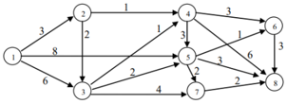

|  |
| --- |
| For testing in the lab. program |
| 3 1 1  8 0 3 6 -1 8 -1 -1 -1 -1 0 2 1 -1 -1 -1 -1 -1 -1 0 1 2 -1 4 -1 -1 -1 -1 0 3 3 -1 6 -1 -1 -1 -1 0 1 2 3 -1 -1 -1 -1 -1 0 -1 3 -1 -1 -1 -1 -1 -1 0 2 -1 -1 -1 -1 -1 -1 -1 0  0 |

Drumul maxim

|  |  |  |  |  |  |  |  |  |
| --- | --- | --- | --- | --- | --- | --- | --- | --- |
|  | 1 | 2 | 3 | 4 | 5 | 6 | 7 | 8 |
| 1 | 0 | 3 | 6 | -∞ | 8 | -∞ | -∞ | -∞ |
| 2 | -∞ | 0 | 2 | 1 | -∞ | -∞ | -∞ | -∞ |
| 3 | -∞ | -∞ | 0 | 1 | 2 | -∞ | 4 | -∞ |
| 4 | -∞ | -∞ | -∞ | 0 | 3 | 3 | -∞ | 6 |
| 5 | -∞ | -∞ | -∞ | -∞ | 0 | 1 | 2 | 3 |
| 6 | -∞ | -∞ | -∞ | -∞ | -∞ | 0 | -∞ | 3 |
| 7 | -∞ | -∞ | -∞ | -∞ | -∞ | -∞ | 0 | 2 |
| 8 | -∞ | -∞ | -∞ | -∞ | -∞ | -∞ | -∞ | 0 |
| V1 | -∞ | -∞ | -∞ | 6 | 3 | 3 | 2 | 0 |
| V2 | 11 | 7 | 7 | 6 | 4 | 3 | 2 | 0 |
| V3 | 13 | 9 | 7 | 7 | 4 | 3 | 2 | 0 |
| V4 | 13 | 9 | 8 | 7 | 4 | 3 | 2 | 0 |
| V5 | 14 | 10 | 8 | 7 | 4 | 3 | 2 | 0 |
| V6 | 14 | 10 | 8 | 7 | 4 | 3 | 2 | 0 |

Lmax=14

1->3->4->5->6->8

1->3->4->5->7->8

**Drumul Hamiltonian**

|  |  |  |  |  |  |  |
| --- | --- | --- | --- | --- | --- | --- |
|  | 1 | 2 | 3 | 4 | 5 | 6 |
| 1 |  | 1 |  |  |  |  |
| 2 |  |  |  |  |  |  |
| 3 |  |  |  |  |  |  |
| 4 |  |  |  |  |  |  |
| 5 |  |  |  |  |  |  |
| 6 |  |  |  |  |  |  |